- Program ID : VS004MA1

- Display Layout
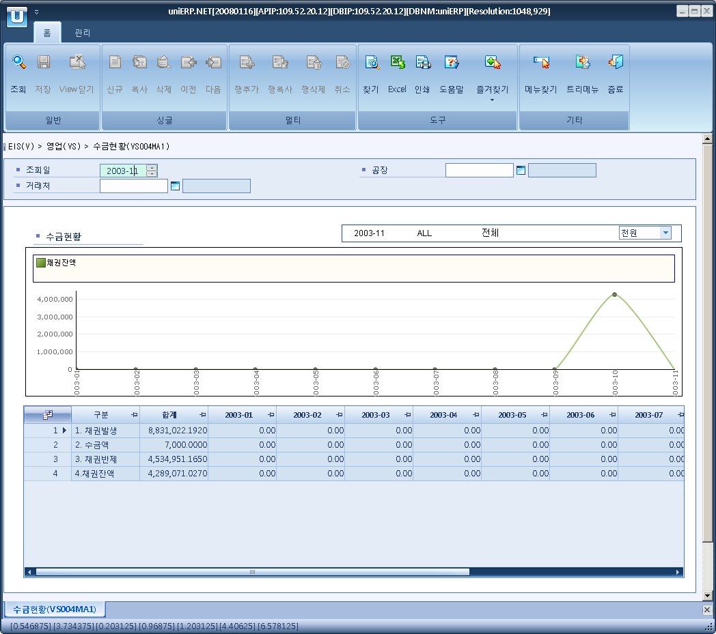

- Event flow
- Click Query button
- OnFncQuery -> DbQuery -> DataChange
- Display Unit combo change
- uniCombo1_ValueChanged -> DataChange

- SQL Statements
- Collection status
SELECT '1. 채권발생' AS flag,
ISNULL(SUM(a.bill_amt_loc + a.vat_amt_loc), 0) AS sum_amt,
ISNULL(SUM(CASE WHEN CONVERT(VARCHAR(6), a.bill_dt, 112) = @fisc_yyyymm THEN a.bill_amt_loc + a.vat_amt_loc ELSE 0 END), 0) AS mon01,
ISNULL(SUM(CASE WHEN CONVERT(VARCHAR(6), a.bill_dt, 112) = CONVERT(VARCHAR(6), DATEADD(MONTH, 1, @fisc_yyyymm + '01'), 112) THEN a.bill_amt_loc + a.vat_amt_loc ELSE 0 END), 0) AS mon02,
ISNULL(SUM(CASE WHEN CONVERT(VARCHAR(6), a.bill_dt, 112) = CONVERT(VARCHAR(6), DATEADD(MONTH, 2, @fisc_yyyymm + '01'), 112) THEN a.bill_amt_loc + a.vat_amt_loc ELSE 0 END), 0) AS mon03,
ISNULL(SUM(CASE WHEN CONVERT(VARCHAR(6), a.bill_dt, 112) = CONVERT(VARCHAR(6), DATEADD(MONTH, 3, @fisc_yyyymm + '01'), 112) THEN a.bill_amt_loc + a.vat_amt_loc ELSE 0 END), 0) AS mon04,
ISNULL(SUM(CASE WHEN CONVERT(VARCHAR(6), a.bill_dt, 112) = CONVERT(VARCHAR(6), DATEADD(MONTH, 4, @fisc_yyyymm + '01'), 112) THEN a.bill_amt_loc + a.vat_amt_loc ELSE 0 END), 0) AS mon05,
ISNULL(SUM(CASE WHEN CONVERT(VARCHAR(6), a.bill_dt, 112) = CONVERT(VARCHAR(6), DATEADD(MONTH, 5, @fisc_yyyymm + '01'), 112) THEN a.bill_amt_loc + a.vat_amt_loc ELSE 0 END), 0) AS mon06,
ISNULL(SUM(CASE WHEN CONVERT(VARCHAR(6), a.bill_dt, 112) = CONVERT(VARCHAR(6), DATEADD(MONTH, 6, @fisc_yyyymm + '01'), 112) THEN a.bill_amt_loc + a.vat_amt_loc ELSE 0 END), 0) AS mon07,
ISNULL(SUM(CASE WHEN CONVERT(VARCHAR(6), a.bill_dt, 112) = CONVERT(VARCHAR(6), DATEADD(MONTH, 7, @fisc_yyyymm + '01'), 112) THEN a.bill_amt_loc + a.vat_amt_loc ELSE 0 END), 0) AS mon08,
ISNULL(SUM(CASE WHEN CONVERT(VARCHAR(6), a.bill_dt, 112) = CONVERT(VARCHAR(6), DATEADD(MONTH, 8, @fisc_yyyymm + '01'), 112) THEN a.bill_amt_loc + a.vat_amt_loc ELSE 0 END), 0) AS mon09,
ISNULL(SUM(CASE WHEN CONVERT(VARCHAR(6), a.bill_dt, 112) = CONVERT(VARCHAR(6), DATEADD(MONTH, 9, @fisc_yyyymm + '01'), 112) THEN a.bill_amt_loc + a.vat_amt_loc ELSE 0 END), 0) AS mon10,
ISNULL(SUM(CASE WHEN CONVERT(VARCHAR(6), a.bill_dt, 112) = CONVERT(VARCHAR(6), DATEADD(MONTH, 10, @fisc_yyyymm + '01'), 112) THEN a.bill_amt_loc + a.vat_amt_loc ELSE 0 END), 0) AS mon11,
ISNULL(SUM(CASE WHEN CONVERT(VARCHAR(6), a.bill_dt, 112) = CONVERT(VARCHAR(6), DATEADD(MONTH, 11, @fisc_yyyymm + '01'), 112) THEN a.bill_amt_loc + a.vat_amt_loc ELSE 0 END), 0) AS mon12
FROM s_bill_hdr a(NOLOCK)
INNER JOIN b_sales_grp c(NOLOCK)
ON a.sales_grp = c.sales_grp
INNER JOIN b_cost_center d(NOLOCK)
ON c.cost_cd = d.cost_cd
INNER JOIN (SELECT DISTINCT biz_area_cd
FROM b_plant(NOLOCK)
WHERE plant_cd LIKE @strPlantCd) e
ON d.biz_area_cd = e.biz_area_cd
WHERE a.bill_dt >= @fisc_yyyymm + '01'
AND a.bill_dt < DATEADD(MONTH, 1, @strYyyyMm + '01')
AND a.post_flag = 'Y'
AND a.bill_to_party LIKE @strBpCd
UNION ALL
SELECT '2. 수금액' AS flag,
ISNULL(SUM(a.collect_amt_loc), 0) AS sum_amt,
ISNULL(SUM(CASE WHEN CONVERT(VARCHAR(6), a.bill_dt, 112) = @fisc_yyyymm THEN a.collect_amt_loc ELSE 0 END), 0) AS mon01,
ISNULL(SUM(CASE WHEN CONVERT(VARCHAR(6), a.bill_dt, 112) = CONVERT(VARCHAR(6), DATEADD(MONTH, 1, @fisc_yyyymm + '01'), 112) THEN a.collect_amt_loc ELSE 0 END), 0) AS mon02,
ISNULL(SUM(CASE WHEN CONVERT(VARCHAR(6), a.bill_dt, 112) = CONVERT(VARCHAR(6), DATEADD(MONTH, 2, @fisc_yyyymm + '01'), 112) THEN a.collect_amt_loc ELSE 0 END), 0) AS mon03,
ISNULL(SUM(CASE WHEN CONVERT(VARCHAR(6), a.bill_dt, 112) = CONVERT(VARCHAR(6), DATEADD(MONTH, 3, @fisc_yyyymm + '01'), 112) THEN a.collect_amt_loc ELSE 0 END), 0) AS mon04,
ISNULL(SUM(CASE WHEN CONVERT(VARCHAR(6), a.bill_dt, 112) = CONVERT(VARCHAR(6), DATEADD(MONTH, 4, @fisc_yyyymm + '01'), 112) THEN a.collect_amt_loc ELSE 0 END), 0) AS mon05,
ISNULL(SUM(CASE WHEN CONVERT(VARCHAR(6), a.bill_dt, 112) = CONVERT(VARCHAR(6), DATEADD(MONTH, 5, @fisc_yyyymm + '01'), 112) THEN a.collect_amt_loc ELSE 0 END), 0) AS mon06,
ISNULL(SUM(CASE WHEN CONVERT(VARCHAR(6), a.bill_dt, 112) = CONVERT(VARCHAR(6), DATEADD(MONTH, 6, @fisc_yyyymm + '01'), 112) THEN a.collect_amt_loc ELSE 0 END), 0) AS mon07,
ISNULL(SUM(CASE WHEN CONVERT(VARCHAR(6), a.bill_dt, 112) = CONVERT(VARCHAR(6), DATEADD(MONTH, 7, @fisc_yyyymm + '01'), 112) THEN a.collect_amt_loc ELSE 0 END), 0) AS mon08,
ISNULL(SUM(CASE WHEN CONVERT(VARCHAR(6), a.bill_dt, 112) = CONVERT(VARCHAR(6), DATEADD(MONTH, 8, @fisc_yyyymm + '01'), 112) THEN a.collect_amt_loc ELSE 0 END), 0) AS mon09,
ISNULL(SUM(CASE WHEN CONVERT(VARCHAR(6), a.bill_dt, 112) = CONVERT(VARCHAR(6), DATEADD(MONTH, 9, @fisc_yyyymm + '01'), 112) THEN a.collect_amt_loc ELSE 0 END), 0) AS mon10,
ISNULL(SUM(CASE WHEN CONVERT(VARCHAR(6), a.bill_dt, 112) = CONVERT(VARCHAR(6), DATEADD(MONTH, 10, @fisc_yyyymm + '01'), 112) THEN a.collect_amt_loc ELSE 0 END), 0) AS mon11,
ISNULL(SUM(CASE WHEN CONVERT(VARCHAR(6), a.bill_dt, 112) = CONVERT(VARCHAR(6), DATEADD(MONTH, 11, @fisc_yyyymm + '01'), 112) THEN a.collect_amt_loc ELSE 0 END), 0) AS mon12
FROM s_bill_hdr a(NOLOCK)
INNER JOIN b_sales_grp c(NOLOCK)
ON a.sales_grp = c.sales_grp
INNER JOIN b_cost_center d(NOLOCK)
ON c.cost_cd = d.cost_cd
INNER JOIN (SELECT DISTINCT biz_area_cd
FROM b_plant(NOLOCK)
WHERE plant_cd LIKE @strPlantCd) e
ON d.biz_area_cd = e.biz_area_cd
WHERE a.bill_dt >= @fisc_yyyymm + '01'
AND a.bill_dt < DATEADD(MONTH, 1, @strYyyyMm + '01')
AND a.post_flag = 'Y'
AND a.bill_to_party LIKE @strBpCd
UNION ALL
SELECT '3. 채권반제' AS flag,
ISNULL(SUM(a.cls_loc_amt), 0) AS sum_amt,
ISNULL(SUM(CASE WHEN CONVERT(VARCHAR(6), a.cls_dt, 112) = @fisc_yyyymm THEN a.cls_loc_amt ELSE 0 END), 0) AS mon01,
ISNULL(SUM(CASE WHEN CONVERT(VARCHAR(6), a.cls_dt, 112) = CONVERT(VARCHAR(6), DATEADD(MONTH, 1, @fisc_yyyymm + '01'), 112) THEN a.cls_loc_amt ELSE 0 END), 0) AS mon02,
ISNULL(SUM(CASE WHEN CONVERT(VARCHAR(6), a.cls_dt, 112) = CONVERT(VARCHAR(6), DATEADD(MONTH, 2, @fisc_yyyymm + '01'), 112) THEN a.cls_loc_amt ELSE 0 END), 0) AS mon03,
ISNULL(SUM(CASE WHEN CONVERT(VARCHAR(6), a.cls_dt, 112) = CONVERT(VARCHAR(6), DATEADD(MONTH, 3, @fisc_yyyymm + '01'), 112) THEN a.cls_loc_amt ELSE 0 END), 0) AS mon04,
ISNULL(SUM(CASE WHEN CONVERT(VARCHAR(6), a.cls_dt, 112) = CONVERT(VARCHAR(6), DATEADD(MONTH, 4, @fisc_yyyymm + '01'), 112) THEN a.cls_loc_amt ELSE 0 END), 0) AS mon05,
ISNULL(SUM(CASE WHEN CONVERT(VARCHAR(6), a.cls_dt, 112) = CONVERT(VARCHAR(6), DATEADD(MONTH, 5, @fisc_yyyymm + '01'), 112) THEN a.cls_loc_amt ELSE 0 END), 0) AS mon06,
ISNULL(SUM(CASE WHEN CONVERT(VARCHAR(6), a.cls_dt, 112) = CONVERT(VARCHAR(6), DATEADD(MONTH, 6, @fisc_yyyymm + '01'), 112) THEN a.cls_loc_amt ELSE 0 END), 0) AS mon07,
ISNULL(SUM(CASE WHEN CONVERT(VARCHAR(6), a.cls_dt, 112) = CONVERT(VARCHAR(6), DATEADD(MONTH, 7, @fisc_yyyymm + '01'), 112) THEN a.cls_loc_amt ELSE 0 END), 0) AS mon08,
ISNULL(SUM(CASE WHEN CONVERT(VARCHAR(6), a.cls_dt, 112) = CONVERT(VARCHAR(6), DATEADD(MONTH, 8, @fisc_yyyymm + '01'), 112) THEN a.cls_loc_amt ELSE 0 END), 0) AS mon09,
ISNULL(SUM(CASE WHEN CONVERT(VARCHAR(6), a.cls_dt, 112) = CONVERT(VARCHAR(6), DATEADD(MONTH, 9, @fisc_yyyymm + '01'), 112) THEN a.cls_loc_amt ELSE 0 END), 0) AS mon10,
ISNULL(SUM(CASE WHEN CONVERT(VARCHAR(6), a.cls_dt, 112) = CONVERT(VARCHAR(6), DATEADD(MONTH, 10, @fisc_yyyymm + '01'), 112) THEN a.cls_loc_amt ELSE 0 END), 0) AS mon11,
ISNULL(SUM(CASE WHEN CONVERT(VARCHAR(6), a.cls_dt, 112) = CONVERT(VARCHAR(6), DATEADD(MONTH, 11, @fisc_yyyymm + '01'), 112) THEN a.cls_loc_amt ELSE 0 END), 0) AS mon12
FROM a_cls_ar a(NOLOCK)
INNER JOIN a_open_ar b(NOLOCK)
ON a.ar_no = b.ar_no
AND b.ar_type = 'AR'
AND b.pay_bp_cd LIKE @strBpCd
INNER JOIN b_cost_center d(NOLOCK)
ON b.cost_cd = d.cost_cd
INNER JOIN (SELECT DISTINCT biz_area_cd
FROM b_plant(NOLOCK)
WHERE plant_cd LIKE @strPlantCd) e
ON d.biz_area_cd = e.biz_area_cd
WHERE a.cls_dt >= @fisc_yyyymm + '01'
AND a.cls_dt < DATEADD(MONTH, 1, @strYyyyMm + '01')
UNION ALL
SELECT '4.채권잔액',
ISNULL(SUM(a.ar_amt), 0) AS sum_amt,
ISNULL(SUM(CASE WHEN a.qdate = @fisc_yyyymm THEN a.ar_amt ELSE 0 END), 0) AS mon01,
ISNULL(SUM(CASE WHEN a.qdate = CONVERT(VARCHAR(6), DATEADD(MONTH, 1, @fisc_yyyymm + '01'), 112) THEN a.ar_amt ELSE 0 END), 0) AS mon02,
ISNULL(SUM(CASE WHEN a.qdate = CONVERT(VARCHAR(6), DATEADD(MONTH, 2, @fisc_yyyymm + '01'), 112) THEN a.ar_amt ELSE 0 END), 0) AS mon03,
ISNULL(SUM(CASE WHEN a.qdate = CONVERT(VARCHAR(6), DATEADD(MONTH, 3, @fisc_yyyymm + '01'), 112) THEN a.ar_amt ELSE 0 END), 0) AS mon04,
ISNULL(SUM(CASE WHEN a.qdate = CONVERT(VARCHAR(6), DATEADD(MONTH, 4, @fisc_yyyymm + '01'), 112) THEN a.ar_amt ELSE 0 END), 0) AS mon05,
ISNULL(SUM(CASE WHEN a.qdate = CONVERT(VARCHAR(6), DATEADD(MONTH, 5, @fisc_yyyymm + '01'), 112) THEN a.ar_amt ELSE 0 END), 0) AS mon06,
ISNULL(SUM(CASE WHEN a.qdate = CONVERT(VARCHAR(6), DATEADD(MONTH, 6, @fisc_yyyymm + '01'), 112) THEN a.ar_amt ELSE 0 END), 0) AS mon07,
ISNULL(SUM(CASE WHEN a.qdate = CONVERT(VARCHAR(6), DATEADD(MONTH, 7, @fisc_yyyymm + '01'), 112) THEN a.ar_amt ELSE 0 END), 0) AS mon08,
ISNULL(SUM(CASE WHEN a.qdate = CONVERT(VARCHAR(6), DATEADD(MONTH, 8, @fisc_yyyymm + '01'), 112) THEN a.ar_amt ELSE 0 END), 0) AS mon09,
ISNULL(SUM(CASE WHEN a.qdate = CONVERT(VARCHAR(6), DATEADD(MONTH, 9, @fisc_yyyymm + '01'), 112) THEN a.ar_amt ELSE 0 END), 0) AS mon10,
ISNULL(SUM(CASE WHEN a.qdate = CONVERT(VARCHAR(6), DATEADD(MONTH, 10, @fisc_yyyymm + '01'), 112) THEN a.ar_amt ELSE 0 END), 0) AS mon11,
ISNULL(SUM(CASE WHEN a.qdate = CONVERT(VARCHAR(6), DATEADD(MONTH, 11, @fisc_yyyymm + '01'), 112) THEN a.ar_amt ELSE 0 END), 0) AS mon12
FROM (SELECT CONVERT(VARCHAR(6), a.ar_dt, 112) AS qdate, a.ar_loc_amt AS ar_amt
FROM a_open_ar a(NOLOCK) INNER JOIN b_cost_center d(NOLOCK) ON a.cost_cd = d.cost_cd
INNER JOIN (SELECT DISTINCT biz_area_cd FROM b_plant(NOLOCK)
WHERE plant_cd LIKE @strPlantCd) e ON d.biz_area_cd = e.biz_area_cd
WHERE a.ar_dt >= @fisc_yyyymm + '01'
AND a.ar_dt < DATEADD(MONTH, 1, @strYyyyMm + '01')
AND a.ar_type = 'AR'
AND a.pay_bp_cd LIKE @strBpCd
UNION ALL
SELECT CONVERT(VARCHAR(6), b.cls_dt, 112), -b.cls_loc_amt - b.dc_loc_amt
FROM a_cls_ar b(NOLOCK) INNER JOIN a_open_ar a(NOLOCK) ON a.ar_no = b.ar_no
AND a.ar_type = 'AR'
AND a.pay_bp_cd LIKE @strBpCd
INNER JOIN b_cost_center d(NOLOCK) ON a.cost_cd = d.cost_cd
INNER JOIN (SELECT DISTINCT biz_area_cd FROM b_plant(NOLOCK)
WHERE plant_cd LIKE @strPlantCd) e ON d.biz_area_cd = e.biz_area_cd
WHERE b.cls_dt >= @fisc_yyyymm + '01'
AND b.cls_dt < DATEADD(MONTH, 1, @strYyyyMm + '01')
UNION ALL
SELECT CONVERT(VARCHAR(6), b.adjust_dt, 112), -b.adjust_loc_amt
FROM a_ar_adjust b(NOLOCK) INNER JOIN a_open_ar a(NOLOCK) ON a.ar_no = b.ar_no
AND a.ar_type = 'AR'
AND a.pay_bp_cd LIKE @strBpCd
INNER JOIN b_cost_center d(NOLOCK)
ON a.cost_cd = d.cost_cd
INNER JOIN (SELECT DISTINCT biz_area_cd
FROM b_plant(NOLOCK)
WHERE plant_cd LIKE @strPlantCd) e
ON d.biz_area_cd = e.biz_area_cd
WHERE b.adjust_dt >= @fisc_yyyymm + '01'
AND b.adjust_dt < DATEADD(MONTH, 1, @strYyyyMm + '01')) a

